**FUNCTIONAL AND TECHNICAL COMBINED DOCUMENTATION**

**Page (17): Add Stocks-Stocks Details (Front End Url:** http://localhost:8100/page17/Page17)

**Functional Picture:**

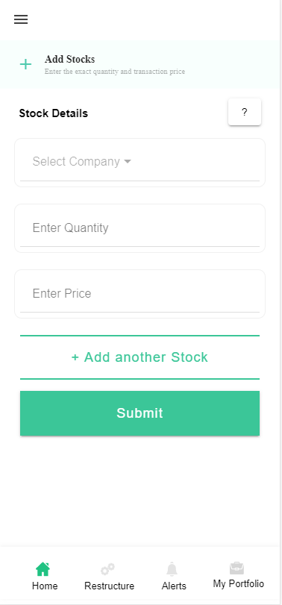

**In this Page, the user can enter the exact quantity, price and name of the Stocks that He/She has transacted by pressing the submit button. They can even add the stocks that are recommended by the EasyVest Team in their portfolio by Pressing “+Add another Stock” button.**

**Technical Explanation (Front End and Back End):**

**In Page17.tsx, we are calling following 1 API:**

1. TradeRegisterAPI: see backend python file. In this we are doing GET, PUT and POST requests.

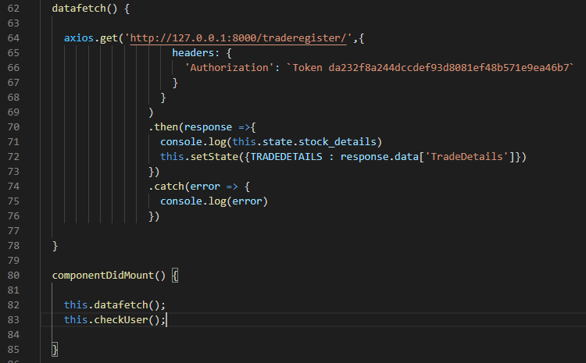

**As you can see, we are calling the** TradeRegisterAPI

**using this url:** [**http://127.0.0.1:8000/traderegister/**](http://127.0.0.1:8000/traderegister/)**. In this we are taking the stocks data to populate it into the Dropdown if at all that user already have some existing stocks. Kindly see the given below backend Code for this GET request.**

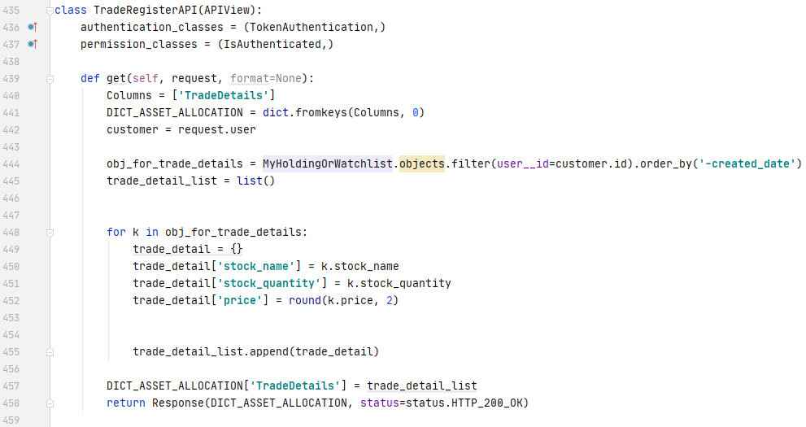

**The Above API is taking the data from the MyHoldingOrWatchlist Database throwing the data on the front end through Response.**

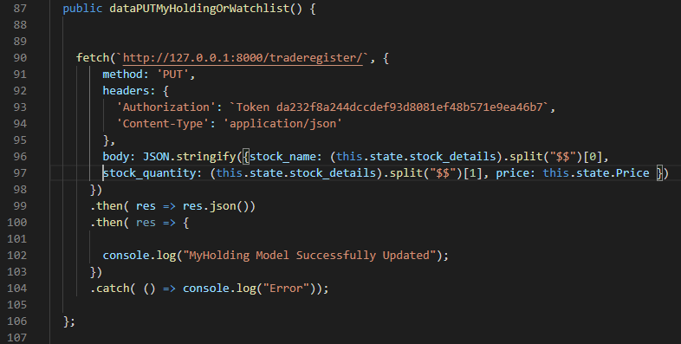

**As you can see, we are calling the** TradeRegisterAPI

**using this url:** [**http://127.0.0.1:8000/traderegister/**](http://127.0.0.1:8000/traderegister/)**. In this we are updating the MyHoldingOrWatchlist Database while the user is updating his/her transaction price. We are calling this function by pressing “Submit” Button. Kindly see the given below backend Code for this PUT request.**

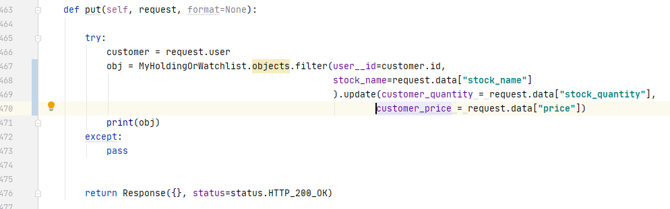

**Here we are updating the one of the MyHoldingOrWatchlist database i.e. MyHoldingOrWatchlistFI model database. Please see this model database in models.py.**

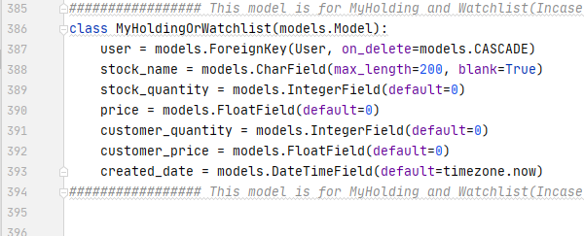

**DONE!!!**